Simply Learn

A simple platform solution for students with bandwidth restriction to ease their burden

About

Simplylearn is a learning platform that helps students from all over the world to study and interact with their instructors in a much efficient and more comfortable way. Simplylearn helps every student learn faster and efficiently, even with deficient internet connectivity and internet data usage. This platform is open source as well as free to use for educational purpose.

Teachers can schedule class in our platform and share the link generated with the students. The image in teachers window is dynamically synced with the students window in real-time. This gives students a live class like feel while consuming negligible data. For audio students can make use of free call-in services offered by platforms like <https://www.freeconferencecall.com/>.

Instructions

Prerequisite

In order to use the platform, the PPT or the presentation must be saved as series of jpeg or png images. Please head to using the platform if the images are in the said format else follow along

1.Open the desired file in MS PowerPoint

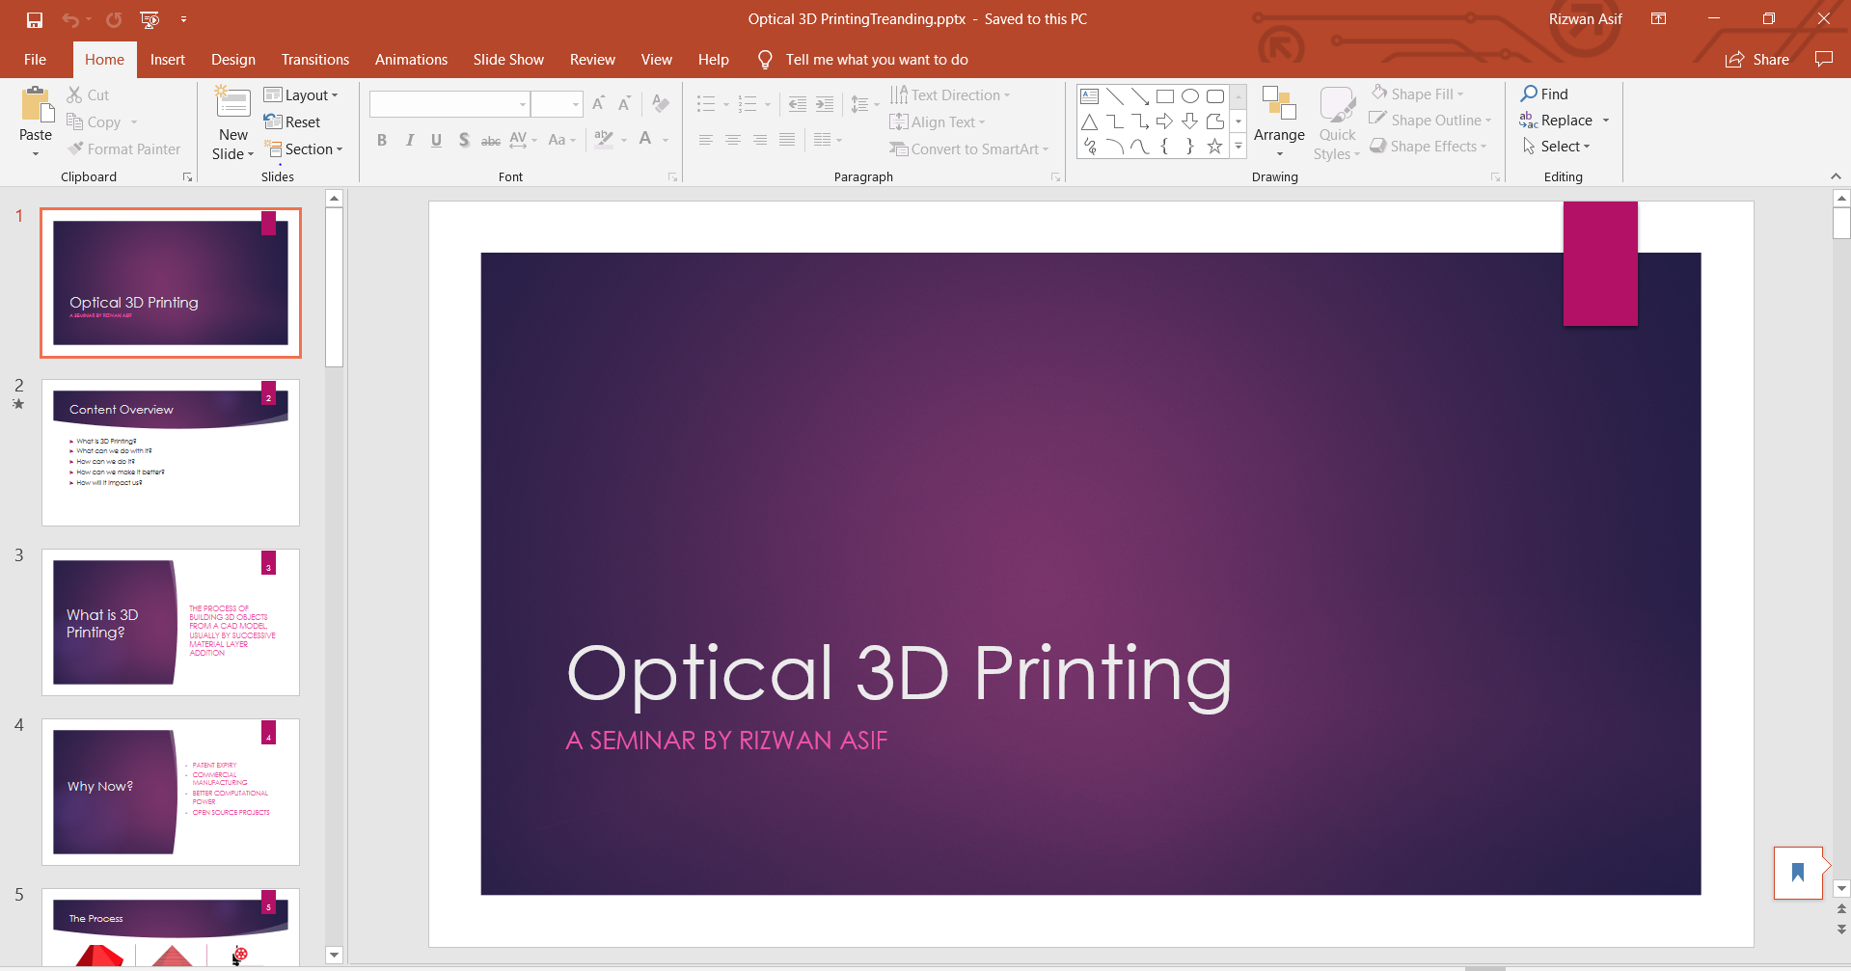

2. Click on Files



3.Click on Save as

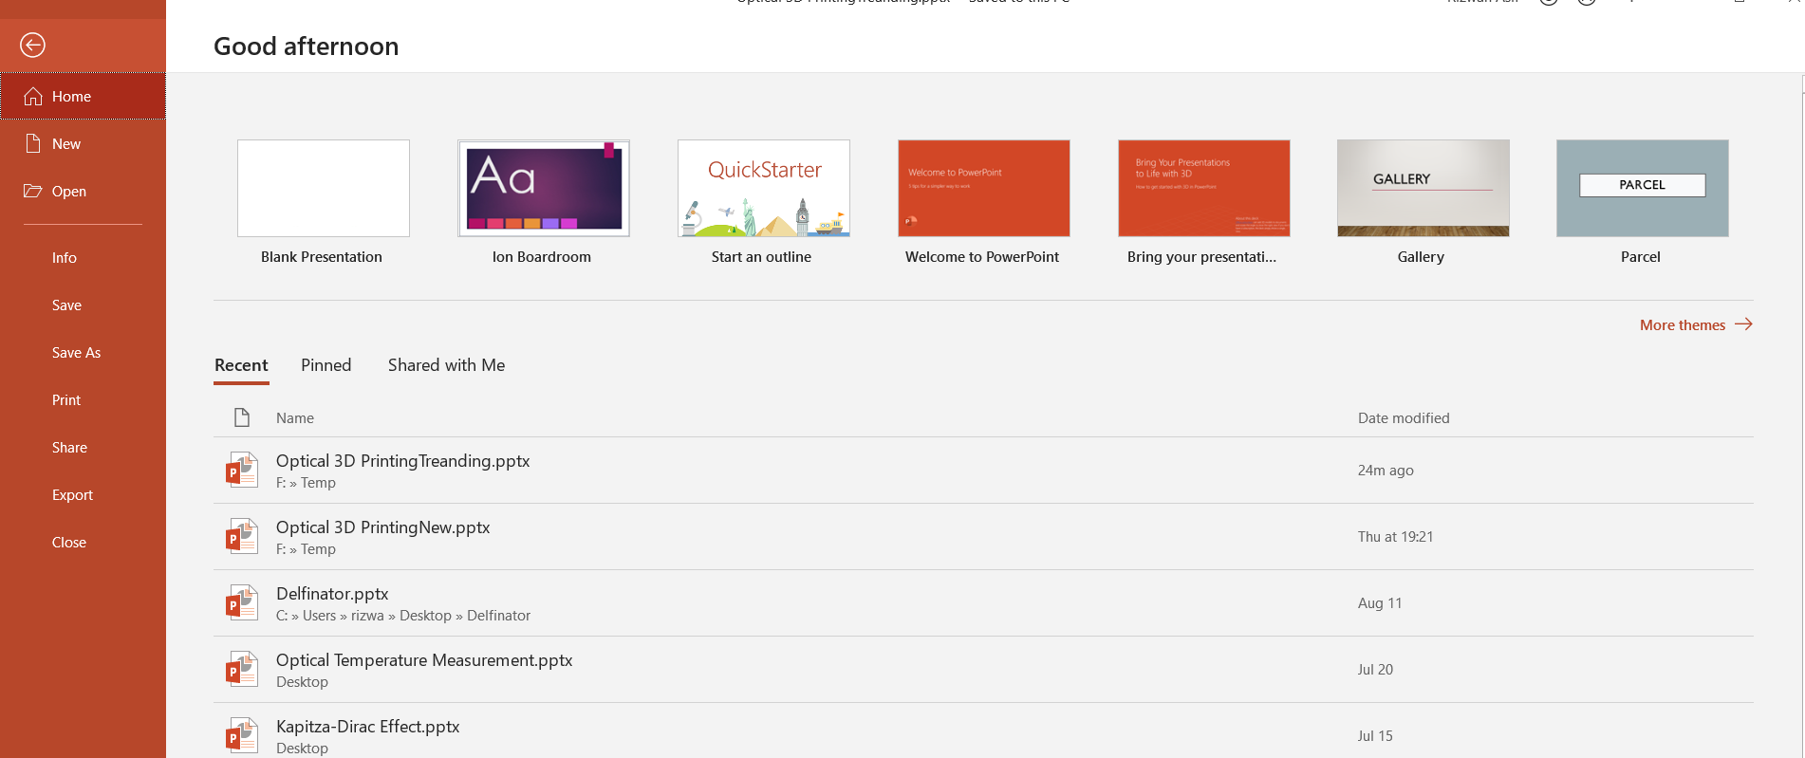

4.Specify the location you want to store and click on save format

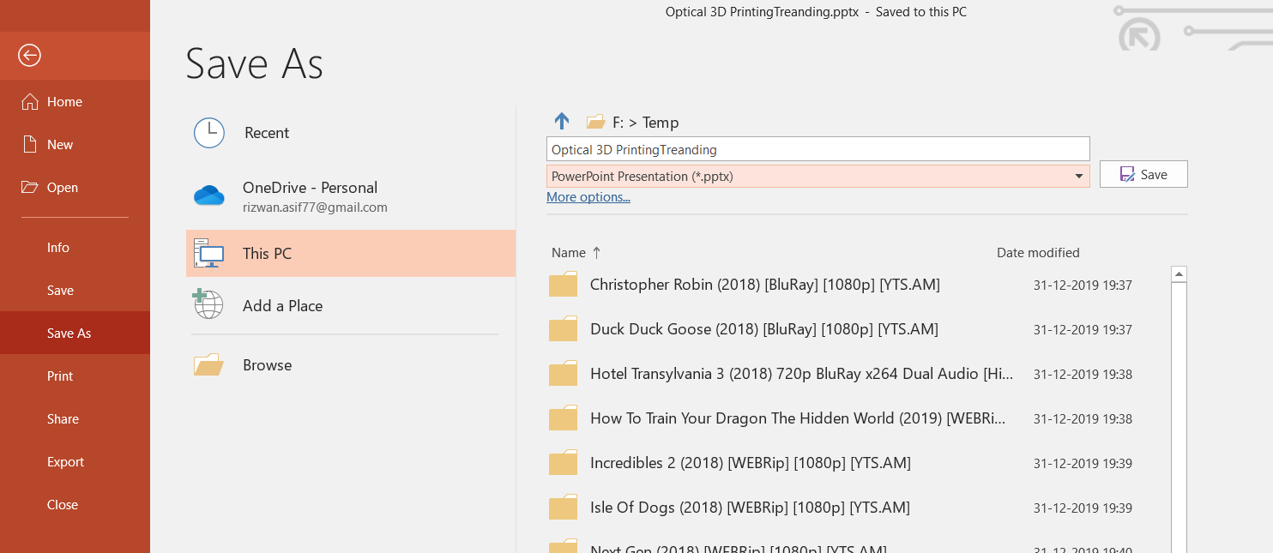

5.Choose .jpg format

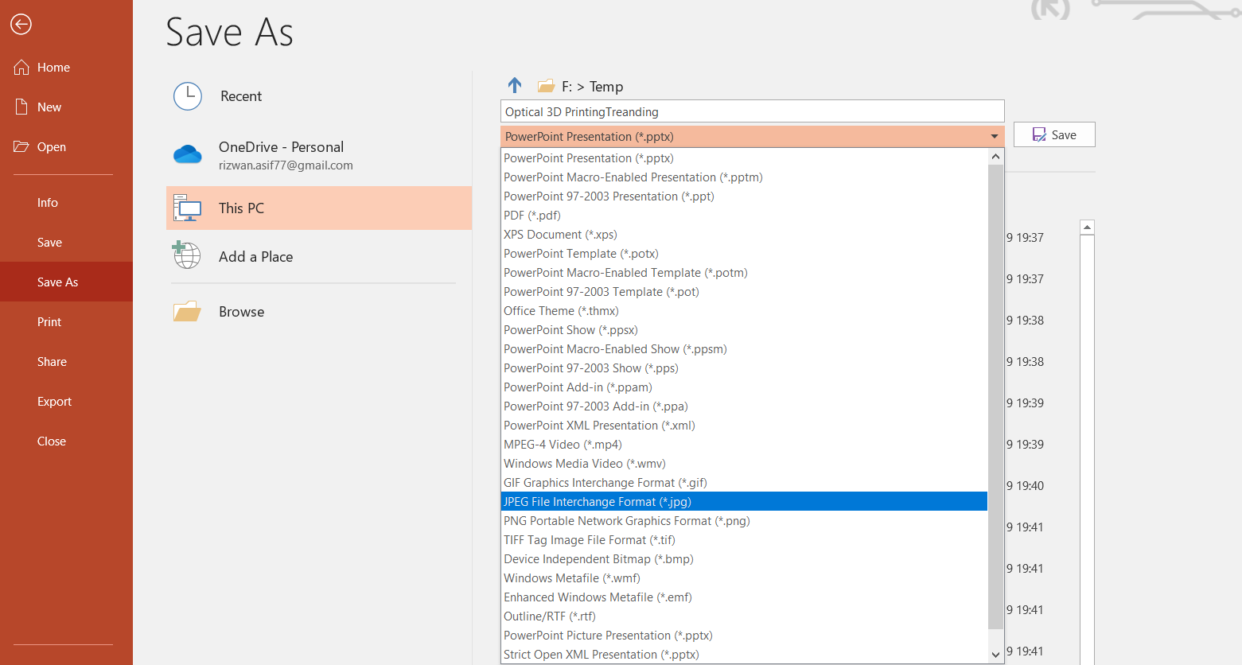

6.Click Save

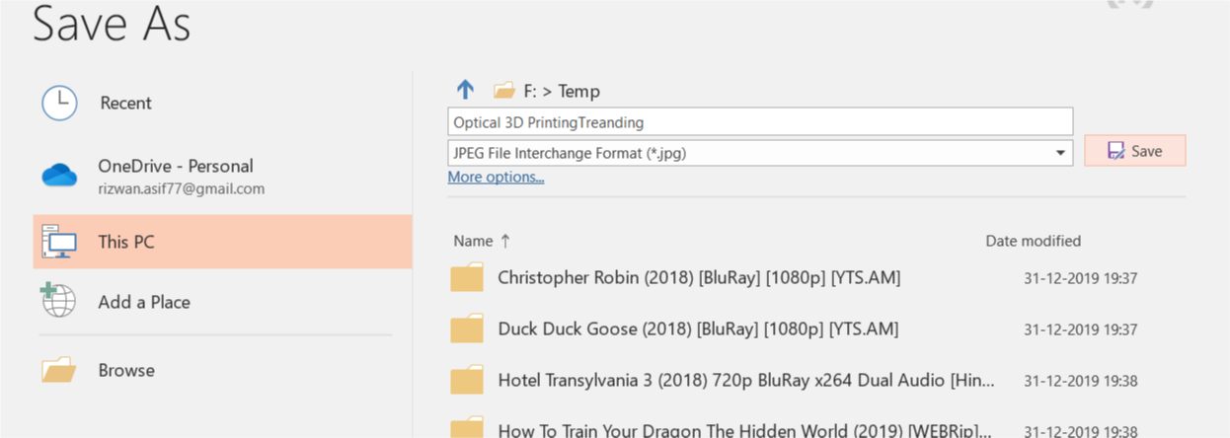

7.When Prompted choose all Slide

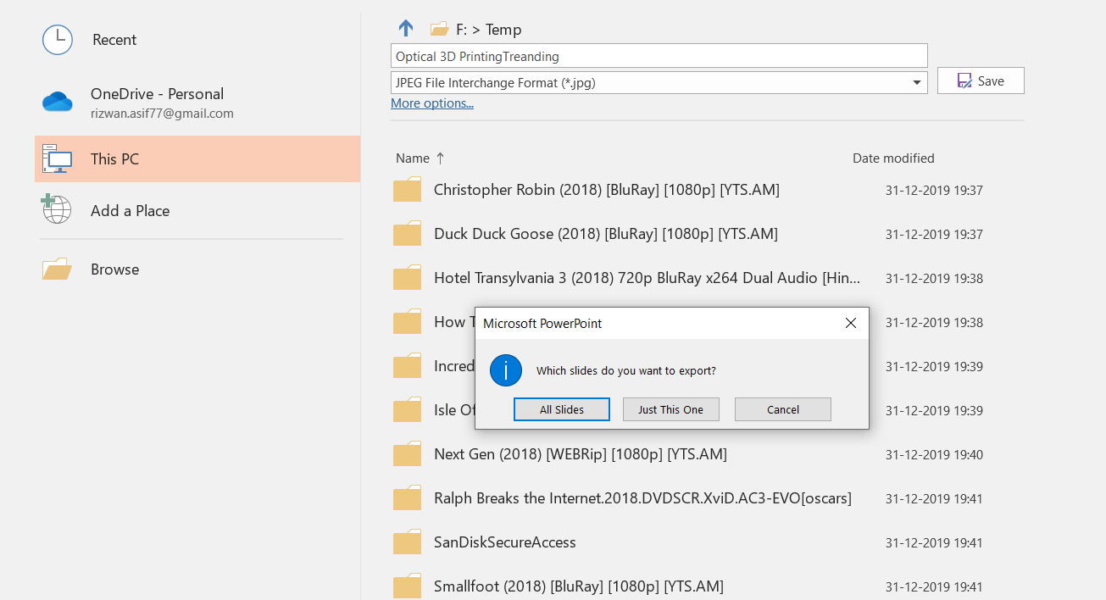

8. If the steps were followed you will find your presentation stored in your specified locations as a series of images

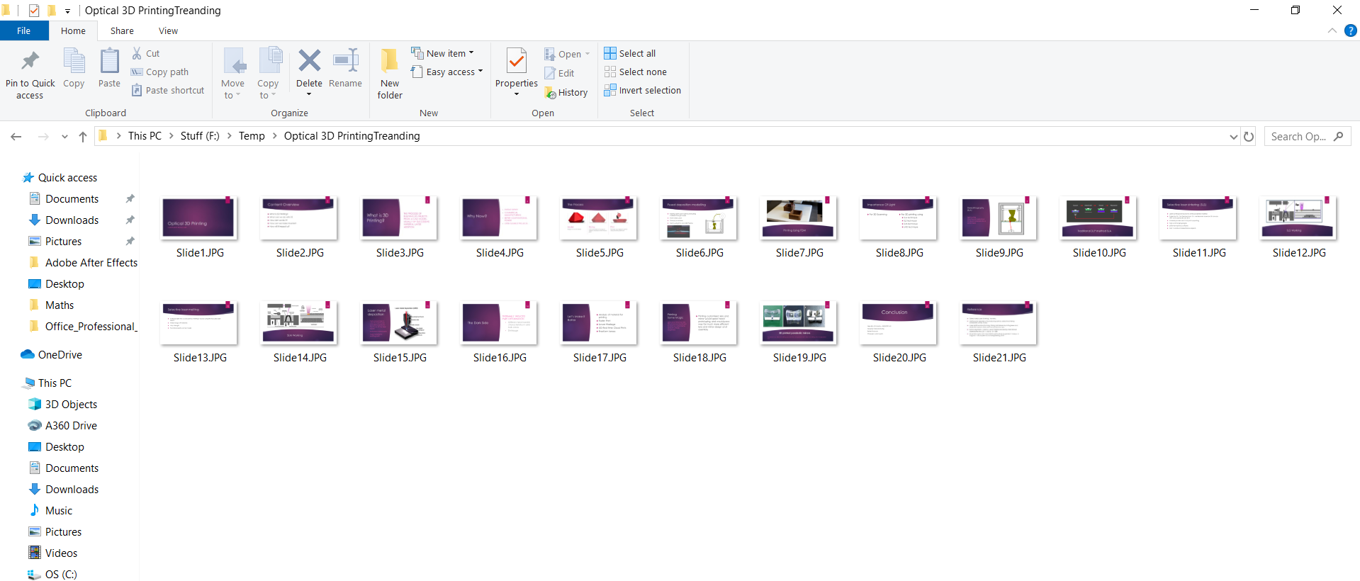

Using The Platform

1.Open The Website/Platform and select TEACHER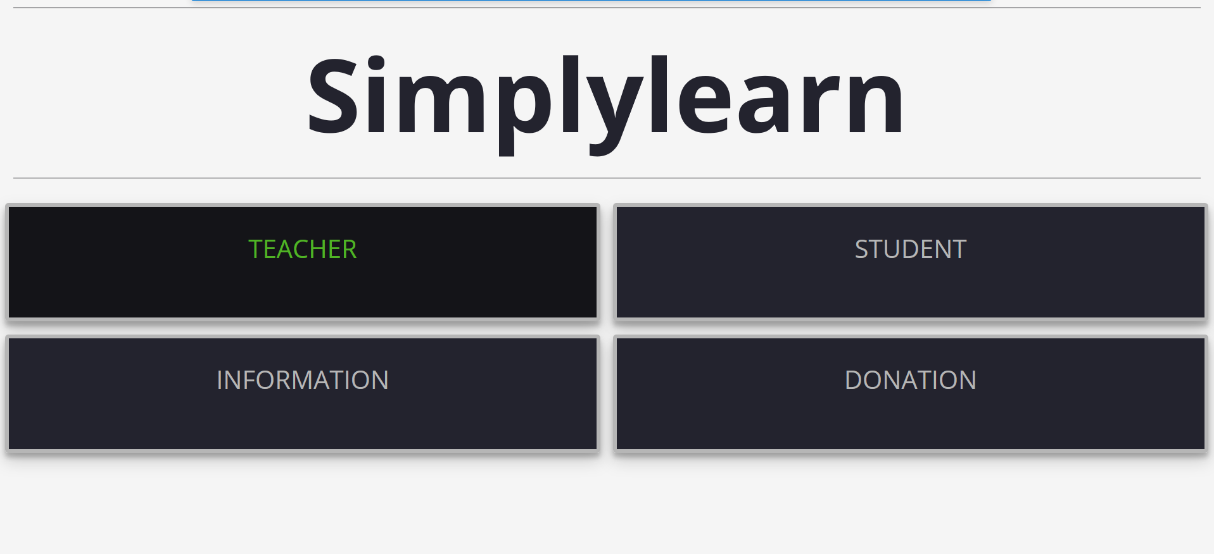

2.Fill the details and click browse to select the file

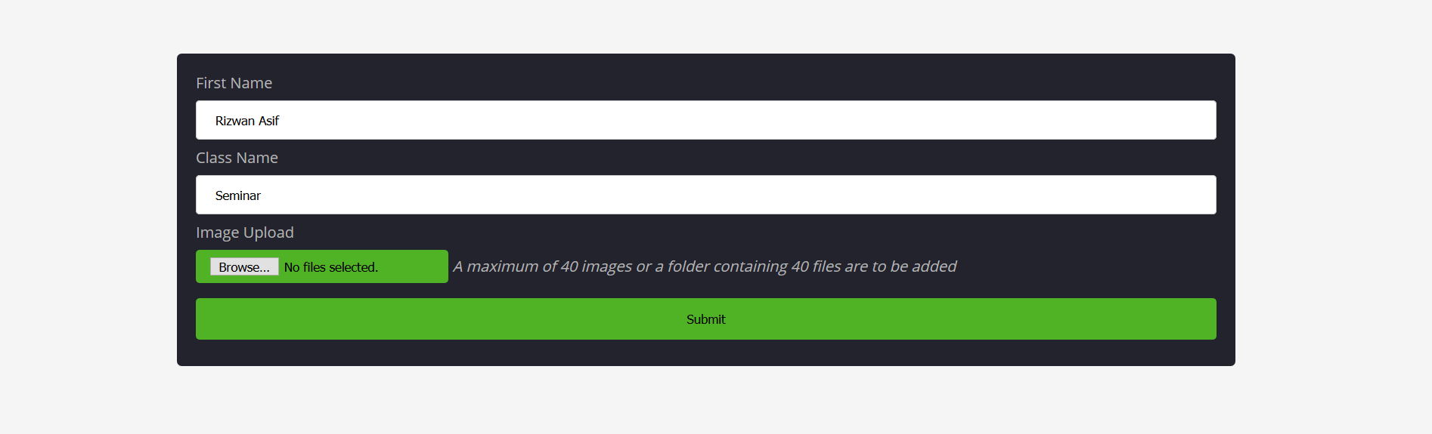

3.Choose the Files save earlier. Press “Ctrl + A” to select all images together or press “Shift” while selecting all images.

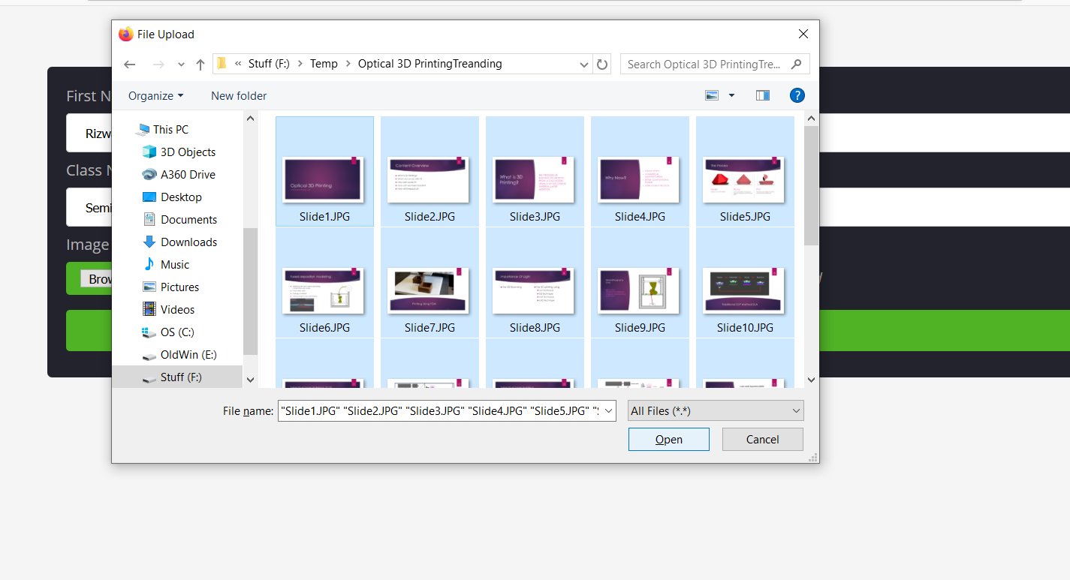

4.Press submit

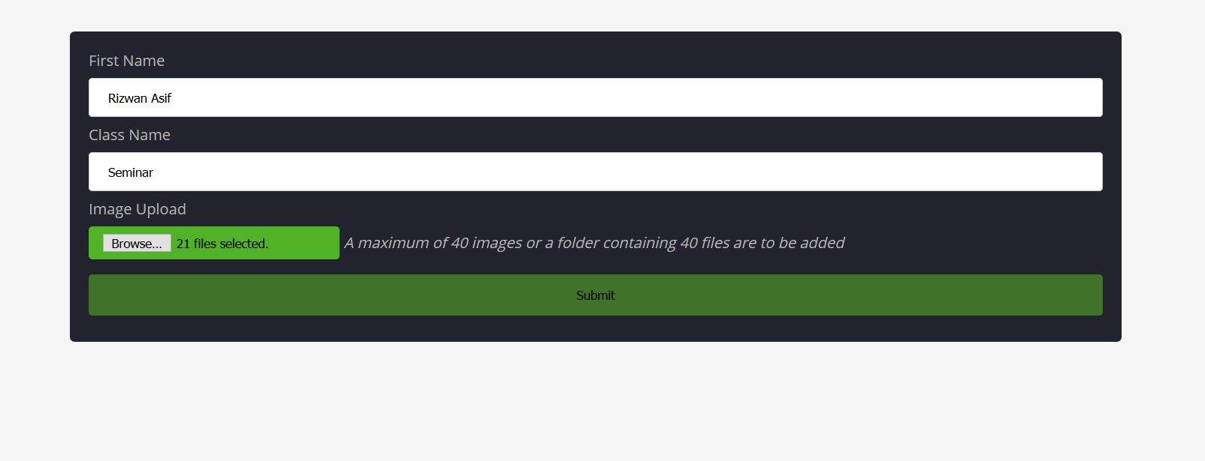

5.Click on Copy or copy the link

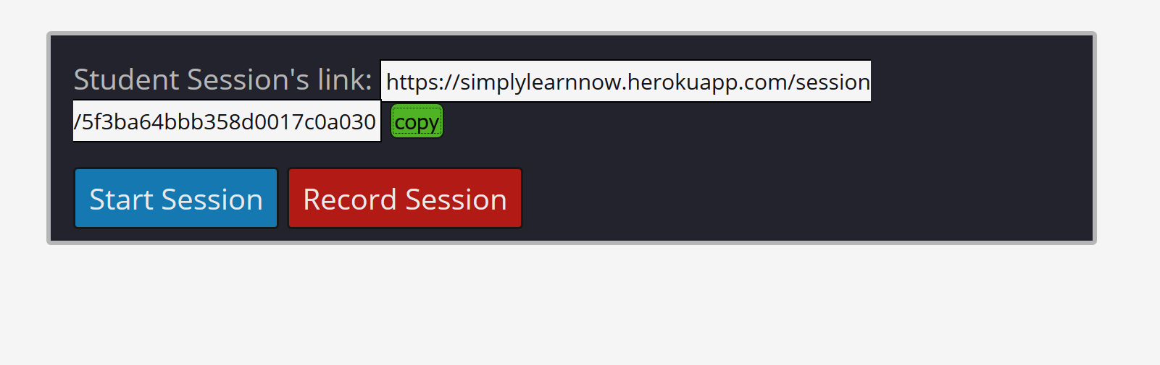

6. Share the copied link via the client of your choice(the link copied is a link in text format, You can sent this students through Whatsapp.Telegram,Mail,SMS etc..)

7.Click on Start Session



8.Change the slides using arrow keys or the arrow button on the screen

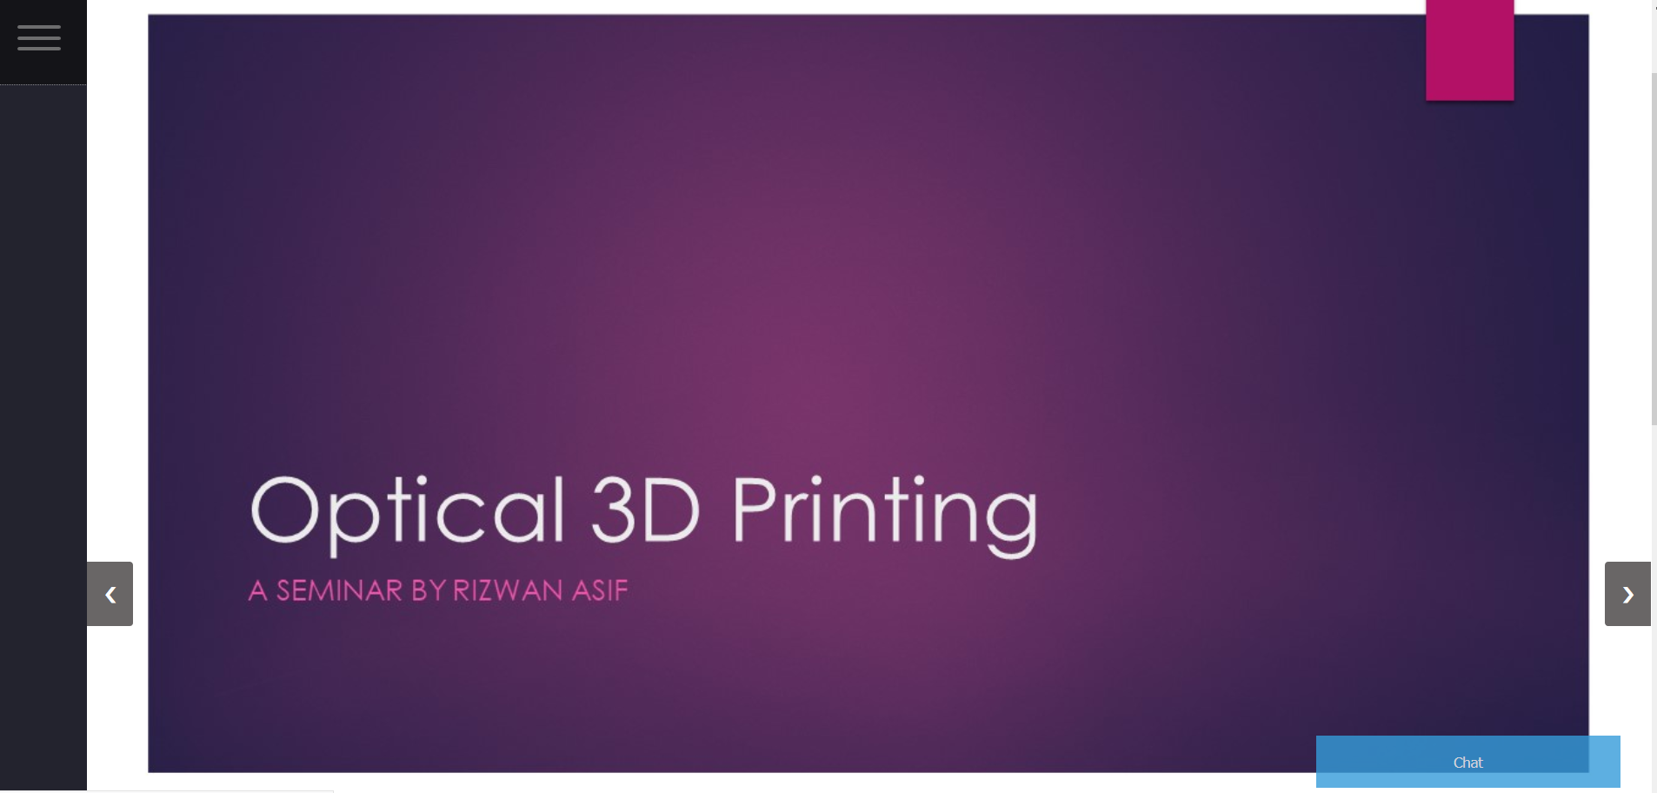

9. You can also jump slide using thumbnails below the live slide.

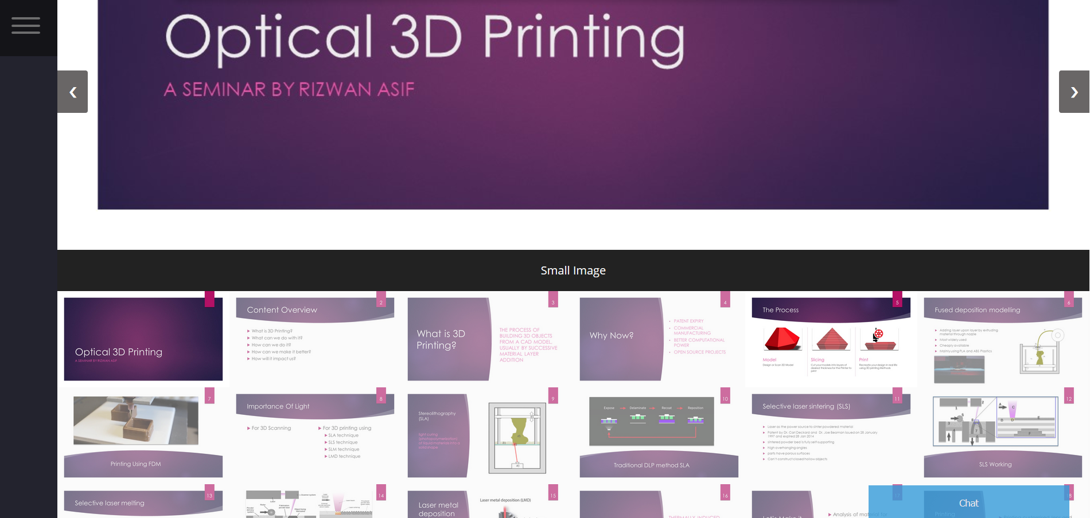

10. List of everyone online can be seen by hovering to the hamburger icon on the top left

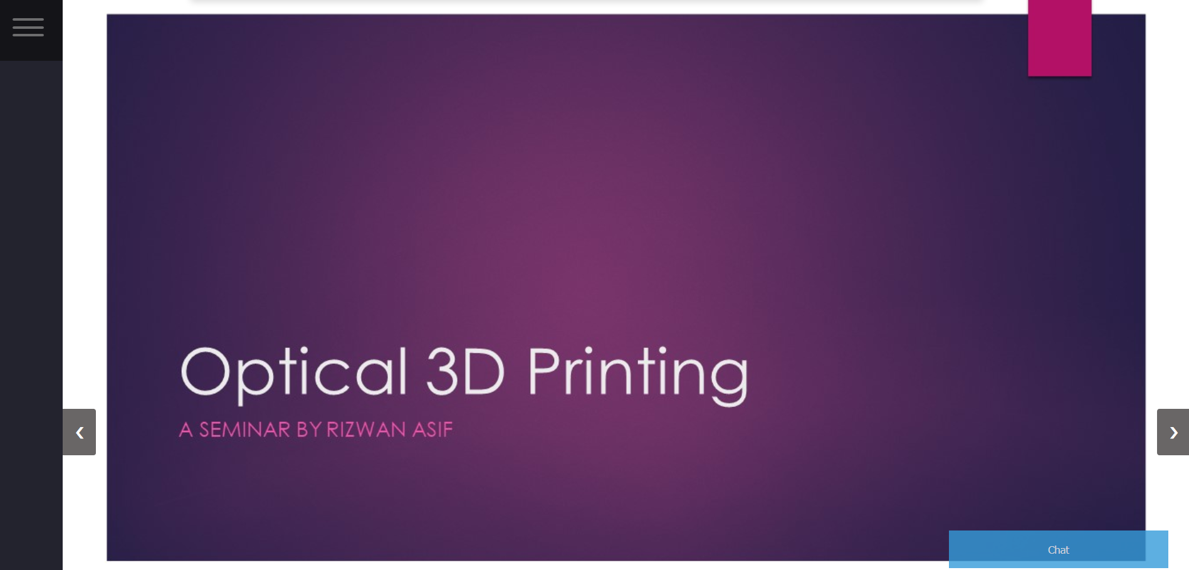

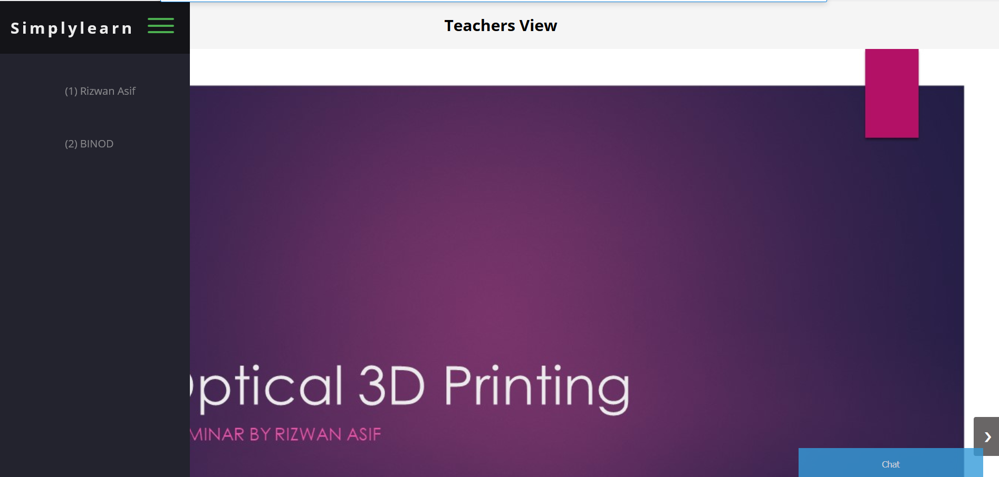 11. The Box on bottom left is the chat box and can be used to chat with students



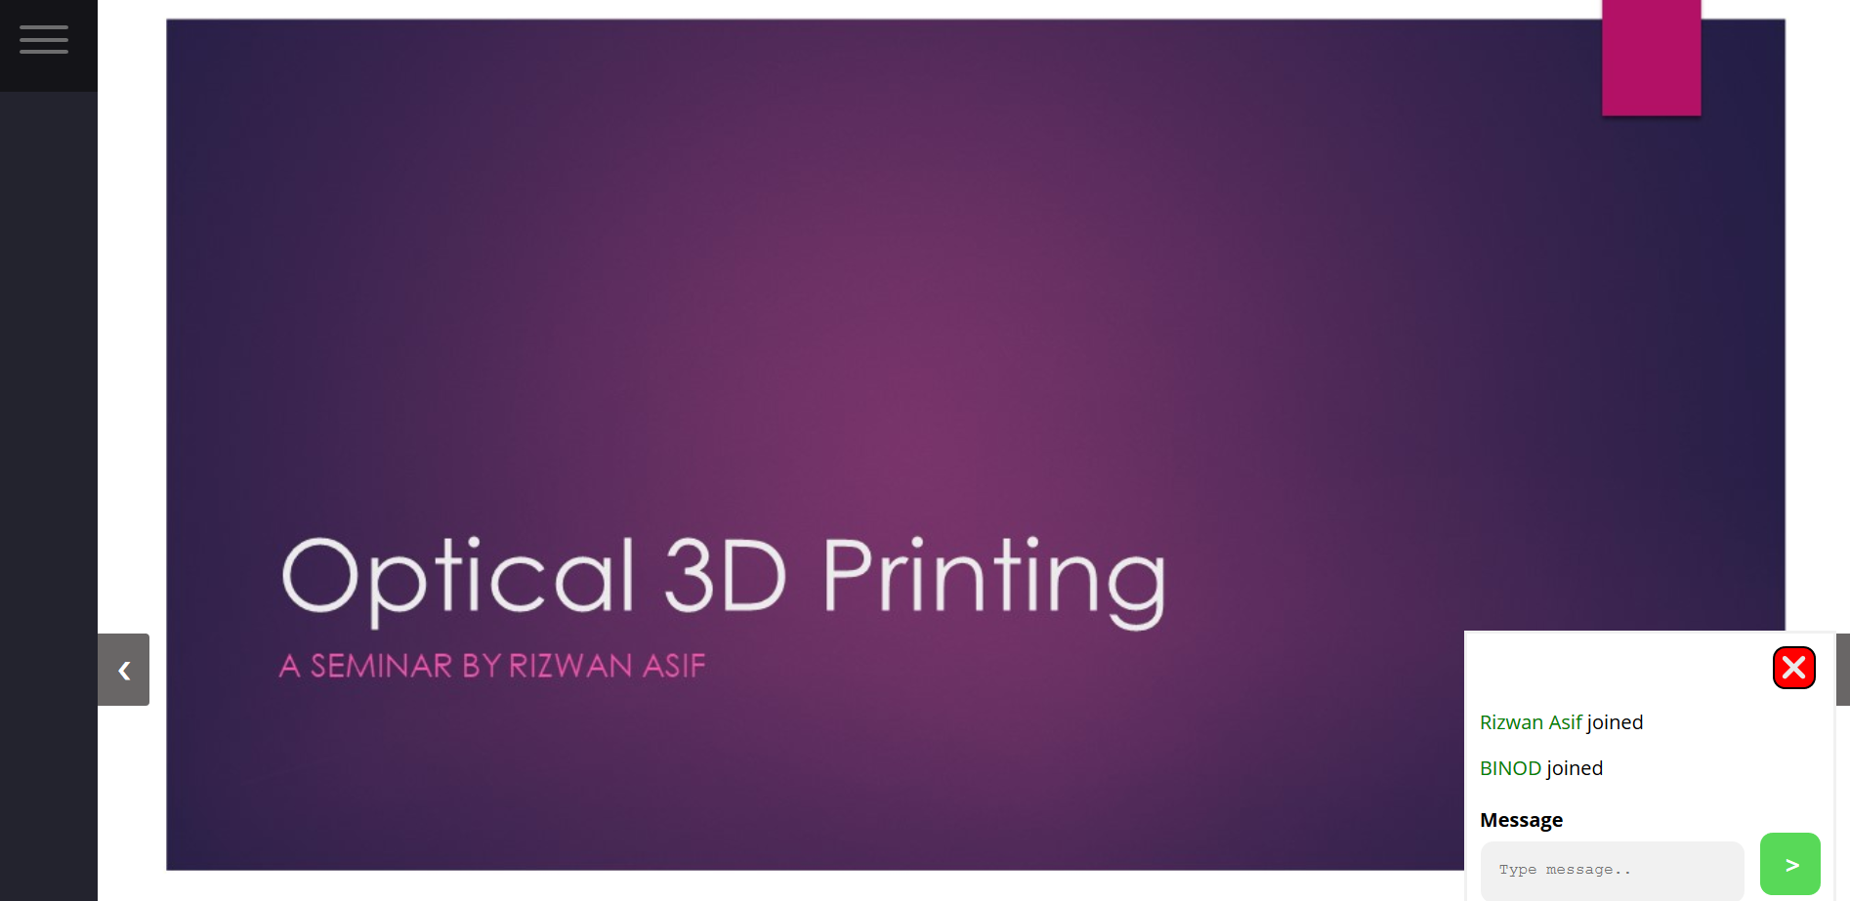

Enjoy the platform.

For any enquiry please contact [kappiinnovations@gmail.com](mailto:kappiinnovations@gmail.com) we will respond back as soon as possible. All suggestions welcome.